Classwork Activity1

Chapter1

1. **Define the following:**
   1. **Firewalls**

Firewalls protect against outside cyber attackers by shielding your computer or network from malicious or unnecessary network traffic ex Microsoft Defender

* 1. **DMZ**

Digital Media Controller, a category within the DLNA standard (for sharing digital media among multimedia devices) tasked with finding content on digital media servers. Discrete memoryless channel.

* 1. **VPN**

A VPN, which stands for virtual private network, protects its users by encrypting their data and masking their IP addresses ex Nord-vpn

* 1. **Hostnames**

A hostname is a unique label assigned to a device connected to a computer network ex wikipedia

* 1. **IP Addresses**

IP address is not assigned to individual hosts but rather used for multicasting ex your ip address.

* 1. **MAC Addresses**

A MAC (Media Access Control) address, sometimes a hardware or physical address, is a unique, 12-character alphanumeric attribute used to identify individual electronic devices on a network ex 00-B0-D0-63-C2-26.

1. **Identify and give a scenario where the following Considerations for a business structure would be addressed:**
   1. **Budget**

A group of friends plans to open a small café in their local neighborhood. They need to decide on the best business structure to ensure financial stability and efficient management.

During their planning meeting, the friends discussed the initial investment required for the café, including rent, equipment, inventory, and staffing. They also project monthly operational costs and potential revenue.

The point of this meeting is to ensure safe money usage and the business survival

* 1. **Skill set**

The group consider how each member will decide what job or task suits them all the best. And decide the following

* + **Friend A:** Experienced barista and pastry chef.
  + **Friend B:** Background in marketing and social media.
  + **Friend C:** Expertise in accounting and finance.
  + **Friend D:** Strong managerial and customer service skills.

They take these skills they have and spread them throughout the company they and encourage those skills in to their assigned jobs to enhance the business

* 1. **Existing infrastructure**

**Scenario**

A tech startup focused on developing a new app is planning to expand its operations. The founders need to decide on the best business structure to make use of their existing infrastructure, including office space, servers, and employee expertise.

Addressing the Existing Infrastructure Consideration:

During a strategic planning session, the founders assess their current infrastructure:

**Office** **Space**: A leased office with room for expansion.

**Technology**: High-performance servers and development tools already in place.

**Employees**: A team of skilled developers, marketers, and support staff.

* 1. **Hardware**

**Scenario Description:**

A growing tech firm that develops software solutions is planning to upgrade its IT hardware to improve performance and support new projects. The company’s executives need to decide on the best business structure to ensure efficient use of their existing and new hardware investments.

**During a strategy meeting,** the executives evaluate their current and planned hardware infrastructure:

**Current Hardware**: Servers, workstations, networking equipment, and storage systems.

**Planned Upgrades:** High-performance servers, advanced workstations for developers, and enhanced networking solutions.  
With the available information, the executives can form strategies to better the hardware requirements and hardware of the business

* 1. **Environment**

**Scenario Description:**

A renewable energy firm specializing in solar and wind energy projects is planning to expand its operations. The firm’s executives need to decide on the best business structure to ensure efficient use of their existing and future environmental assets, including land, solar panels, and wind turbines.

**Considerations**

**Sole Proprietorship:** This structure would place all responsibility and risk on one individual, which is not ideal for a firm managing significant environmental assets and planning large-scale expansions.

**Partnership:** A partnership would allow for shared investment in environmental projects, but personal liability for each partner could be a concern, especially given the regulatory and financial complexities associated with renewable energy projects.

**Limited Liability Company (LLC):** An LLC provides personal liability protection to the owners, making it suitable for managing shared environmental assets. It offers flexibility in management and profit distribution, which can help align environmental investments with the firm’s growth and sustainability goals.

* 1. **The number of users**

**Scenario Description:**

A startup is planning to launch a new social media platform aimed at connecting professionals in niche industries. The founders need to decide on the best business structure to manage and scale the user base efficiently.

**Addressing the Number of Users Consideration:** During a planning meeting, the founders evaluate their current user acquisition strategy and projections for growth:

**Current Users**: Initial beta testers and early adopters.

**Planned Growth**: Scaling to millions of users over the next few years.

**Considerations:**

**Partnership**: A partnership would allow shared responsibility for managing the user base, but personal liability for each partner could be a concern, especially as the user base grows and the platform becomes more complex.

**Limited Liability Company (LLC**): An LLC provides personal liability protection to the owners, making it suitable for managing a growing user base. It offers flexibility in management and profit distribution, which can help align user acquisition strategies with business growth. However, it may have limitations in raising significant capital needed for rapid scaling.

1. **Security**

**Scenario Description:** A team of developers is preparing to launch a cloud-based software company that offers data storage and processing solutions. They need to decide on the best business structure while ensuring robust security measures for their sensitive customer data and intellectual property.

**Data Protection:** Ensuring secure storage and transmission of customer data.

**Intellectual Property:** Protecting proprietary software and algorithms.

**Regulatory Compliance:** Adhering to data protection regulations like GDPR and CCPA.

**Liability Protection:** Minimizing personal liability in case of security breaches or legal issues.

1. **Give examples of the following Network Models and explain how they work:**
   1. **peer-to-peer (P2P) networks**

**Blockchain Network:**

A blockchain network like Bitcoin can track transactions in a decentralized ledger that is maintained by a network of peers.

Each node in a network possesses a copy of the blockchain and validates new transactions based on consensus rules.

* 1. **Client-server networks**

**Email Systems (e.g., Microsoft Exchange):**

In an email system, the email server (server) manages and stores email messages. Email clients (e.g., Outlook, Thunderbird) connect to the server to send, receive, and manage emails.

The server handles tasks like storing emails, managing user accounts, and facilitating email delivery.

* 1. **Wired networks**

**Ethernet Networks:**

Ethernet is a common wired networking technology used in local area networks (LANs).

Devices such as computers, printers, and servers are connected using Ethernet cables (e.g., Cat5e, Cat6) to network switches or routers.

1. **What Is a network HUB**

It is a device that links multiple computers and devices together.  
Hubs cannot filter data, so data packets are sent to all connected devices.  In other words, the collision domain of all hosts connected through the hub remains one.

Hub does not have any routing table to store the data of ports and map destination addresses., the routing table is used to send/broadcast information across all the ports.

1. **What is a network bridge**

Network connection allows several devices to communicate with each other as if they were on the same physical network, even if they are connected to separate networks.

1. **What is a Network Switch**

Networking hardware connects devices on a computer network by using packet switching to receive and forward data to the destination device.

1. **What is Internet Service Providers (ISPs)**

An internet service provider (ISP) is a company that provides access to the internet

1. **Explain VLAN**

Vlan refers to any broadcast domain that is partitioned and isolated in a computer network at the data link layer (OSI layer 2)

1. **What is the difference between Circuit Switching and Packet Switching**

**Circuit Switching**: Establishes a dedicated communication path between two devices for the entire duration of the call. Suitable for real-time applications like voice calls, where a continuous connection is needed.

**Packet Switching:** Breaks data into packets and sends them independently over the network. Packets may take different routes and are reassembled at the destination. Ideal for data transmission where efficiency and flexibility are crucial.

1. **What are some Understanding carrier standards, elaborate their functions**

**Ethernet**

**Function:** Provides high-speed wired network communication. Ethernet standards define how data packets are transmitted over twisted-pair or fibre optic cables. They support various speeds (10 Mbps to 400 Gbps) and are widely used in local area networks (LANs).

**Wi-Fi**

**Function:** Specifies wireless communication protocols for local area networks. Wi-Fi standards (e.g., 802.11a/b/g/n/ac/ax) define how devices connect to a wireless network and manage data transmission over radio frequencies.

**Bluetooth**

**Function:** Facilitates short-range wireless communication between devices, such as smartphones and headsets. Bluetooth standards define protocols for device pairing, data transfer, and communication over short distances (up to 100 meters).

1. **Explain the following:**
   1. **Carrier Sense Multiple Access/Collision Avoidance (CSMA/CA)**

CSMA/CA is a network protocol used in wireless communication to manage how multiple devices share the same frequency channel and avoid data collisions.

* 1. **Radio waves**

Radio waves are used for wireless transmission of sound messages, or information, for communication, as well as for maritime and aircraft navigation.

* 1. **Frequency**

Refer to the strength of your network connection

* 1. **Modulation**

Modulation is the process of encoding information in a transmitted signal, while demodulation is the process of extracting information from the transmitted signal

* 1. **Encryption**

Encryption is used to protect data from being stolen, changed, or compromised

* 1. **MAC filtering**

MAC filtering is a security method based on access control. In this, each address is assigned a 48-bit address which is used to determine whether we can access a network or not.

It helps in listing a set of allowed devices that you need on your Wi-Fi and the list of denied devices that you don't want on your Wi-Fi.

1. **Visually present the structure of these types of Network Topologies**
   1. **Logical topologies versus physical topologies**

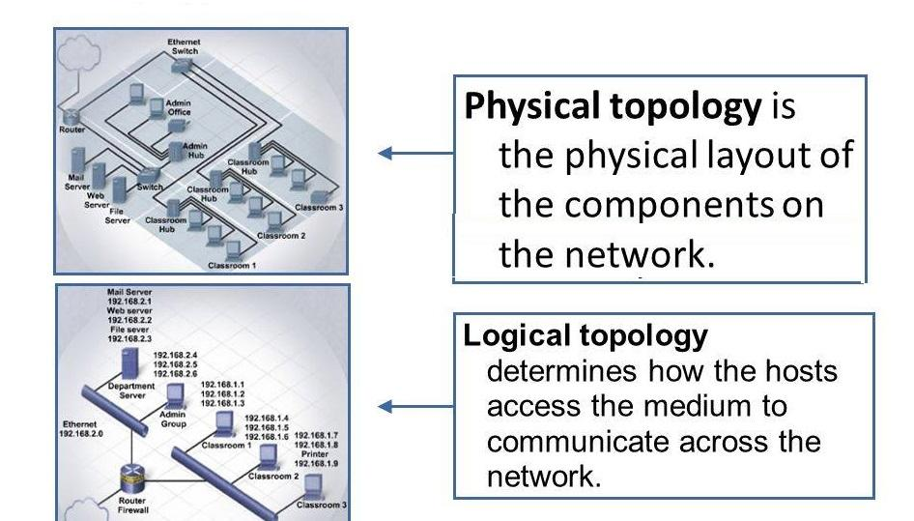

* 1. **Bus topology**

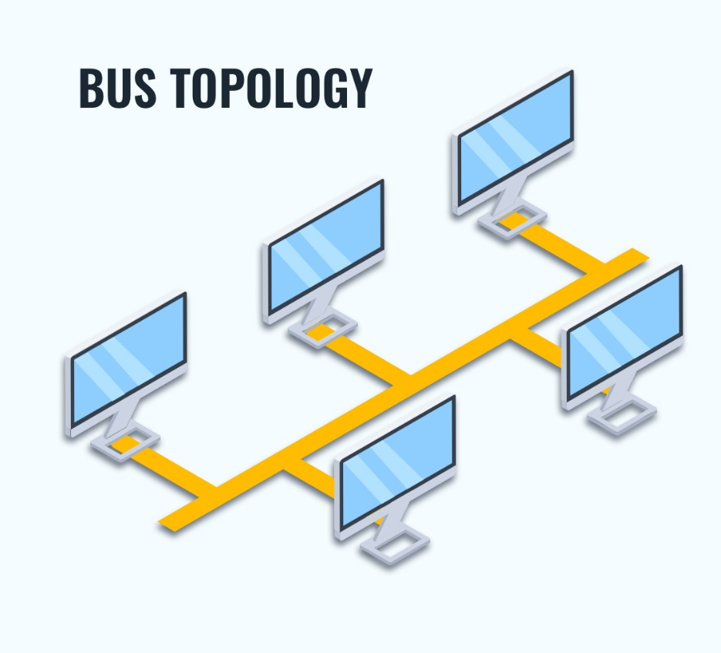

* 1. **Ring topology**

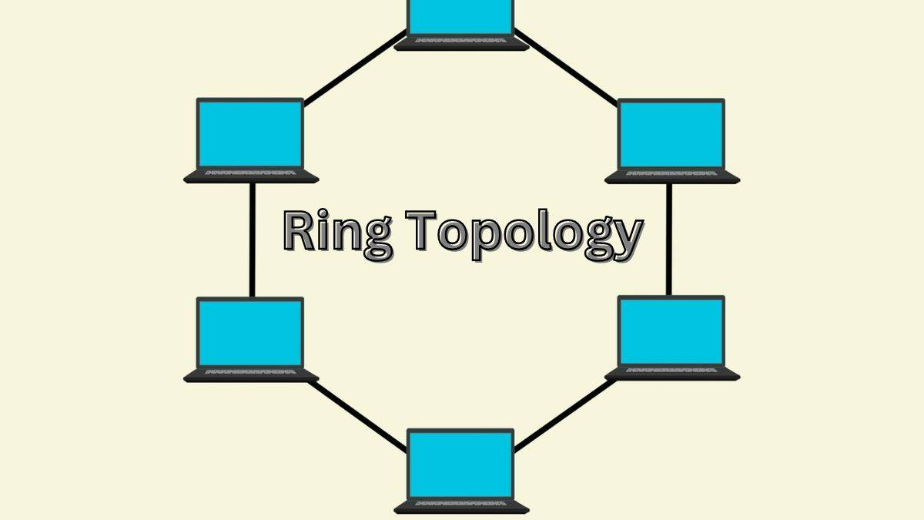

* 1. **Star topology**

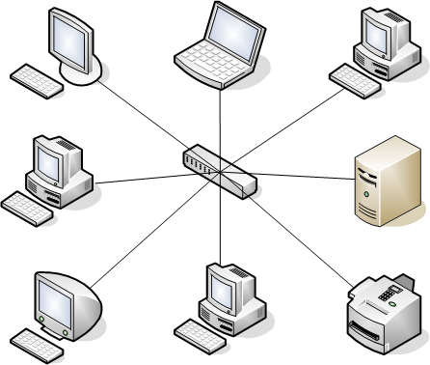

* 1. **Mesh topology**

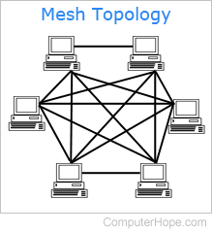

* 1. **Hybrid topology**

